NAUTITEC 54.2
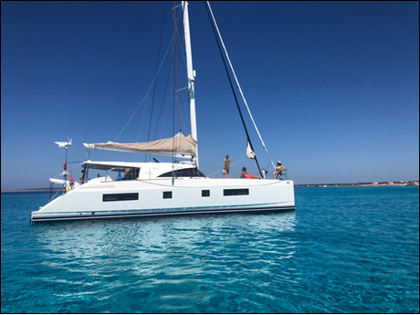

NAUTITECH 54.2 COMBINES LUXURIOUS HOUSING, HIGH-PERFORMANCE WANDERING AND GREEN TECHNOLOGY TO ACHIEVE THE LOWEST POSSIBLE CARBON FOOTPRINT. MANY SOLAR PANELS AND THE ULTRA-QUIET HIGH-POWER GENERATOR

MODEL | NAUTITEC 54.2
YEAR | 2013
FLAG | UK
LENGTH | 17,68 M
BEAM | 8,66 M
DRAFT | 1,55 M
LAYOT | 4 CABINS  4 BATHROOMS
ENGINES | 2 VOLVO PENTA D75  (900 H)
ENGINE POWER | 2 X 75 HP
SAILS | FULL SABLE HYDRAULIC MAJOR TRIRRADIAL 99m2  -HIDRANET TRIRRADIAL FOCUS 46m2  -CODIGOZERO 120m2
FUEL DEPOSIT | 800 L
WATER DEPOSIT | 800 L
LOCATION | VALENCIA

PRICE | 700.000 €
TAXES PAID

NAUTITEC 54.2

EQUIPMENT

ELECTRONICS AND ELECTRICITY  BATTERIES IN BATHROOMS 700AH LITHIUM, BATTERIES ENGINE AND GENERATOR 100AH, FISCHER PANDA GENERATOR 15 KW (2017) ON PORT SIDE, FISCHER PANDA GENERATOR 8 KW (2013) ON STARBOARD SIDE, INVERTER, 3 AUXILIARY CHARGERS, WATER HEATER 2X1200W, AIR CONDITIONING, CHARTPLOTTER, RADAR, AUTOPILOT, VHF  EXTERIOR  SOLAR PANELS, ELECTRIC WINDMILL 400W | INTERIOR  FOUR GUEST SUITES, EACH WITH AIR CONDITIONING, PRIVATE BATHROOM, ELECTRIC TOILET, SHOWERS AND TV, MUSIC AND MOVIES CONTROLLED BY TABLETS THERE ARE NUMEROUS REST AREAS TO CHOOSE FROM - THE FRONT TRAMPOLINES, THE HARDTOP CABIN WITH AN ELECTRIC MOONROOF TO LET IN THE BREEZE OR STARS AND A HUGE MAIN SALOON WITH MANY COMFORTABLE SEATS. AN EXTRA BUNK ON THE STARBOARD SIDE OF THE BOW GIVES SPACE TO THE QUEEN SUITE FOR 2 MORE PEOPLE. | REMARKS  THIS 54' NAUTITECH CATAMARAN COMBINES LUXURIOUS ACCOMMODATION, HIGH PERFORMANCE SAILING AND STATE-OF-THE-ART GREEN TECHNOLOGY TO ACHIEVE THE LOWEST POSSIBLE CARBON FOOTPRINT. WITH THE STATE-OF-THE-ART LITHIUM-ION BATTERY, LED LIGHTING, WIND GENERATOR, MANY SOLAR PANELS AND THE ULTRA-QUIET HIGH-POWERED GENERATOR, THE SILENCE OF THE SUNRISE CAN BE HEARD EVEN IF THE AIR CONDITIONING IS RUNNING.


